

Individual Assignment

Level: 05

Hardware, Microcontrollers and Sensors

M N M SHAHMI
CB016484
Batch Code: COM2521

GitHub Link
https://github.com/mohamedshahmi2004/The-Automated-Commercial-Micro-Climate-Nursery

Contents
1. Scenario & Scope 4
1.1 Chosen Scenario 4
1.2 Prototype Scope 4
1.3 MosCoW Prioritisation 4
1.4 Major Design Decisions 6
2. System Design 7
2.1 Operational Modes and Transitions 7
2.1.2 Mode transition table 8
2.2 Priority Logic Hierarchy (Design Challenge) 8
2.2.2 Complete priority ranking of control rules 10
3. Feature Implementation 11
3.1 Digital I/O 11
3.2 Serial Communication (UART) 11
3.3 ADC - Analogue Input 11
3.4 Timers & Interrupts 12
3.4.1 Cooperative scheduler 12
3.5 PWM - Servo Control 12
3.6 Modes of Operation 13
3.7 Scheduled / Timed Behaviour 13
3.8 I2C - OLED Display 13
4. User Manual 13
4.1 Components 13
4.2 Wiring 14
4.2.1 Pin assignment 14
4.3 Programming the ESP32 17
4.4 First Power-Up Check 17
4.5 Operating Each Mode 18
4.6 Troubleshooting 18
5. Commercial IoT Appraisal 19
5.1 Priva Compact CC 19
5.2 TrolMaster Hydro-X Pro 19
5.3 Comparison 20
6. Testing 21
Refernces 23
Appendix A - Source Code (nursery_controller.ino) 24

1. Scenario & Scope

1.1 Chosen Scenario
This project implements Scenario 2: The Automated Commercial Micro Climate Nursery, from the Agri Tech and industrial greenhouse domain. High value crops grown in indoor nurseries are exposed to two related hazards: sudden midday heat spikes, and pockets of stagnant, humid air that stall growth and encourage disease. Both develop faster than staff can reliably react, which suits an embedded controller that responds within seconds.
The prototype is an ESP32 - based controller that reads indoor temperature, humidity and light level, drives two servo actuated vent windows and a dimmable grow light, and keeps operators informed through an I2C OLED display, three status LEDs and a UART serial terminal. Its priority hierarchy for conflicting conditions is explained in Section 2.2.

1.2 Prototype Scope
What the prototype does. The system is designed to be a one zone, lab bench proof of concept. In autonomous mode, it will read the DHT22 every 2 seconds and the LDR ten times per second; from this information, it will decide how much the vents should open using a priority hierarchy and two different vents will open up sequentially: vent A will respond to small cooling requests, while vent B opens up only after a cooling request of 50% or more. The white grow LED turns on when the light level drops below a threshold and will be modulated by the light deficit using pulse width modulation. In manual override mode, the whole automation process is bypassed and both vents will open according to the position of the potentiometer to allow the operator to put it in any desired position or to the end stop position to open the vents entirely for cleaning purposes.
What the prototype does not do. There is no outdoor weather sensor; the outdoor temperature needed for the design challenge is entered by the operator over UART and defaults to 20 °C. The system does not heat, actively cool, irrigate or dose CO2, and it has no Wi-Fi, cloud dashboard or mobile app. The hobby servos model vent actuators but could not move a real greenhouse window, and the LEDs stand in for horticultural light fixtures. Set points changed over UART are held in RAM and return to their defaults after a reset.

1.3 MosCoW Prioritisation

Priority | Requirements | Status
Must | Read DHT22 temperature and humidity and reject NaN or out of range values | Implemented
Must | Read ambient light from the LDR through the ADC | Implemented
Must | Drive the vent servo(s) with PWM from calculated logic, not fixed positions | Implemented
Must | Switch on supplemental grow lighting automatically in low light | Implemented
Must | OLED shows live temperature, humidity, light level and vent status | Implemented
Must | Three modes (Autonomous, Manual, Safety) with defined transition triggers | Implemented
Must | Manual override that bypasses automation and can lock the vents open; OLED states that automation is suspended | Implemented
Must | Sensor fault detection with safe posture and an OLED warning naming the failed sensor | Implemented
Must | Priority hierarchy that resolves competing conditions (design challenge) | Implemented
Must | Non blocking timing from a hardware timer; UART live status output | Implemented
Should | Two staged vents (A for small demand, B added for large demand) | Implemented
Should | PWM dimmed grow light with on/off hysteresis | Implemented
Should | Set points configurable at runtime over UART with range checking | Implemented
Should | Mode LEDs (Yellow Auto , blue MANNUL) and red fault blink codes | Implemented
Should | Fault latching that requires operator acknowledgement | Implemented
Should | Servo slew rate limiting to product the power supply and mechanism | Implemented
Should | Timed auto resume from Manual Override | Implemented
Could | Fault injection commands for testing and simulation | Implemented
Could | Humidity driven minimum ventilation | Implemented
Could | Grow light derating during critical heat | Implemented
Could | Store set points in flash(NVS) so they survive a reset | Implemented
Could | Buzzer alarm for faults | Not implemented(no buzzer included)
Won’t | Wifi, cloud toggling or mobile app | Out of scope
Won’t | Physical outdoor weather station | Out of scope
Won’t | Heating, active cooling, irrigation or CO2 control | Out of scope
Won’t | Mains rated actuators or multi zone control | Out of scope

The Must Have components arise from the prescribed hardware, the operation of Scenario 2 and the eight prescribed technical features; without at least one of these the prototype will not pass the brief. The Should Have components upgrade the working demo into a controller which can be trusted by the grower: staging, hysteresis and slew limiting prevent output chattering, and fault latching makes sure that a glitching sensor does not allow control to go back to automation without anyone being aware. The Could Have components were included where this was easy and useful for testing purposes. Networking is a Won't Have component since the module looks at embedded control and not at cloud connection; additionally, networking a safety critical controller would introduce security constraints that are not possible to implement within the timeframe. Climate sensors, weather plant and mains actuators require hardware which is not provided.

1.4 Major Design Decisions
Potentiometer as the manual vent control. This requirement only requires that the vents can be locked open by the workers while doing their work. The knob not only enables that but also ensures that any position is achievable by the worker, and the last 3% of movement on both ends locks the vents open or closed.
Operator entered outdoor temperature. The design challenge describes cold outdoor air competing with the need to vent. No outdoor sensor was supplied, so the outdoor temperature is a configuration value set with the UART command "set out". This keeps the frost logic fully testable while being honest that a real installation would use a weather station, as commercial systems do (Section 5).
Two staged vents. Opening one vent first and adding the second only for larger demands gives finer control at low demand and mirrors the commercial practice of opening the lee-side vent before the wind-side vent (Priva, 2026).
Safe posture of 30% vent opening with the grow light off. When the temperature reading cannot be trusted, both extremes are dangerous: closed vents risk the heat spike the scenario is designed to prevent, while fully open vents risk cold damage. A partial opening keeps air moving without large heat exchange. The grow light is switched off because it adds heat that can no longer be measured; missing light is recoverable, heat damage is not. TrolMaster applies similar logic, refusing to run lights without a temperature reading (TrolMaster, n.d.-b).
Fault confirmation and latching. However, at times, the DHT22 may output one corrupt frame, and a fault condition is set after receiving two faulty outputs in succession; this occurs within a period of around four seconds. When a fault is declared, it remains latched until the sensor is operational once more and the fault acknowledged.
Timing and power. The entire timing is done by 10 ms hardware ticks and the cooperative scheduler, meaning that no function locks up the loop. Servos receive power from a different 5V source along with the same ground connection, but only move one degree in 20 ms, since the beginning of motion for two servos at once may result in resetting the ESP32.

2. System Design

2.1 Operational Modes and Transitions
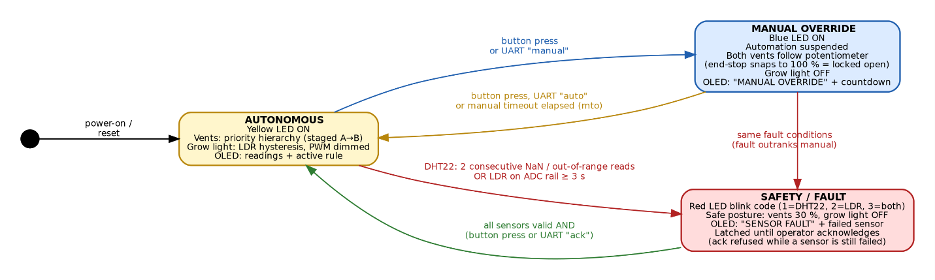

2.1.2 Mode transition table
From | To | Trigger | Code
Power On | AUTONOMOUS | Reset or power applied | State default
AUTONOMOUS | MANUAL | Button press (interrupt) or UART ”manual” | handleButton(),  processCommand()
MANUAL | AUTONOMOUS | Button press, UART "auto", or manual timeout (default 600 s) | handleButton(), updateMode()
AUTONOMOUS or MANUAL | FAULT | DHT22: 2 consecutive NaN /out of range reads; LDR: ADC stuck at a rail for 3 s | readDht(), readAnalogSensors(), updateMode()
FAULT | AUTONOMOUS | All sensors valid AND button press or UART "ack" | tryClearFault()
FAULT | FAULT | Acknowledge attempted while a sensor is still failed: refused and logged | tryClearFault()

There are two features in this state machine that should be clarified. Firstly, the Safety state is ranked higher than the Manual Override state. When a person is working in the Manual state, he uses information from the OLED display to assess the situation, but this information can no longer be trusted if there was a sensor malfunction, and therefore, the system informs him right away. Secondly, when exiting the Safety state, it is always possible to return to the Autonomous state only.

2.2 Priority Logic Hierarchy (Design Challenge)
Within Autonomous mode the vent position is decided by computeVentDemand(), which checks the rules in the order shown in Figure 2. Each rule either decides the result outright or constrains the value produced by the rules before it. Table 3 ranks every rule in the system, including the mode-level rules, from highest to lowest priority.
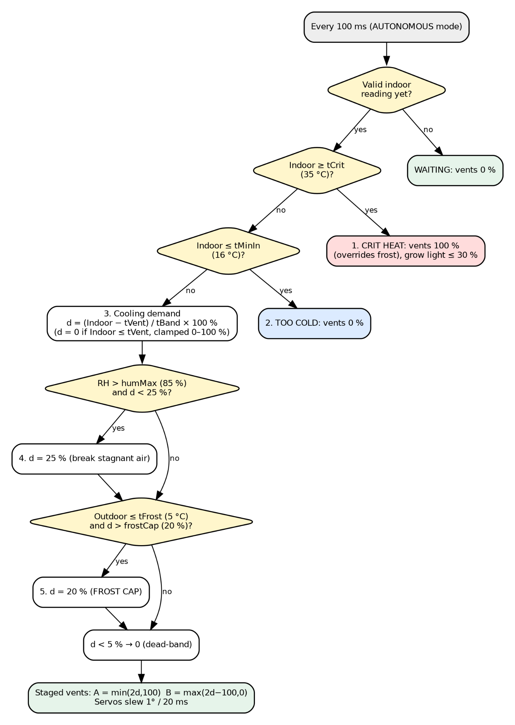

2.2.2 Complete priority ranking of control rules
Rank | Rule | Condition  (default) | Action | Why at this rank
1 | Sensor fault | Invalid DHT22 or LDR | Vents 30%, grow light off | Every other rule depends on valid data
2 | Manual override | Operator selected | Vents follow knob, lights off | A trained person on site has taken responsibility
3 | Critical heat | Indoor ≥ 35 °C | Vents 100%, light ≤ 30% | Heat damage is fast and irreversible
4 | Indoor too cold | Indoor ≤ 16 °C | Vents 0% | Venting could only cool the crop further
5 | Frost cap | Outdoor ≤ 5 °C | Limit vents to 20% | Cold air enters slowly instead of shocking the crop
6 | Air circulation | RH > 85% | Vents at least 25% | Breaks up stagnant, humid air
7 | Proportional cooling | Indoor > 26 °C | Open 0-100% across 26-32 °C | Normal climate control

The ordering is based on how quickly each hazard causes irreversible harm. Critical heat is ranked above the frost cap because plant tissue can be killed by heat within minutes, whereas cold air entering a room that is already at 35 °C is diluted by the warm air and brought to a safe temperature. The frost cap is ranked above both humidity and proportional cooling because at moderate indoor temperatures a slower cooling rate is inconvenient but a blast of freezing air across the crop is damaging.
The design challenge's own example, dangerously cold outside while indoor conditions require venting, shows how these rules combine. With the outdoor temperature at 2 °C and the room at 30 °C, rule 7 requests (30 − 26) / 6 = 67% opening. Rule 5 then caps this at 20%, so vent A opens to 40% of its travel and vent B stays closed. The room still cools, but slowly. If the heat continues to rise and reaches 35 °C, rule 3 takes over and both vents open fully despite the frost, because the room has reached the temperature at which crop loss becomes the greater risk. The OLED header always names the rule in control, for example "AUTO: FROST CAP".
Grow lighting runs as a separate loop because it rarely conflicts with ventilation. The one interaction is heat: during critical heat the light is limited to 30% because the LEDs add heat to a room that is already overheating.

3. Feature Implementation
This section explains how each required embedded feature is implemented, and why that approach was chosen. Function names refer to the source code in Appendix A.

3.1 Digital I/O
The mode button on GPIO4 is configured with the internal pull up resistor, so it reads HIGH when released and LOW when pressed. Its falling edge triggers an interrupt (Section 3.4). The status LEDs are driven at register level by fastWrite(), which writes a single bit to the GPIO_OUT_W1TS ("write 1 to set") or GPIO_OUT_W1TC ("write 1 to clear") register. These registers change one pin without a read modify write sequence, so an interrupt can never corrupt the state of another pin. GPIO33 lies in the ESP32's second GPIO bank, so the function selects the GPIO_OUT1 registers for pins 32 and above (Espressif Systems, 2023). pinMode() is still used once in setup() to configure direction and pull ups, because configuring the IO multiplexer by hand would add risk without any benefit.

3.2 Serial Communication (UART)
UART0 operates at 115200 baud and is used for both directions. For output, printStatusLine() prints the mode, all readings, knob position, vent positions, active rule and fault state every five seconds, and every mode change is logged with its cause. For input, pollSerial() collects characters into a 64 byte buffer without waiting and only acts when a newline arrives, so typing a command never pauses control. Commands are converted to lower case and split with strtok(). Tunable parameters live in a table of name, pointer and limits, so setParam() validates every value in one place.

3.3 ADC - Analogue Input
LDR Divider and Potentiometer are measured by the 12 bit successive approximation ADC in the ESP32, giving values of 0 to 4095. They are connected to ADC1 pins (GPIO34 and GPIO35), because ADC2 cannot be used when the Wi Fi radio is working. To keep the option for future communication open, this choice was made. Because of noise in ESP32 ADC, the function readAdcAvg() calculates average of eight readings, eliminating random noise by factor of about √8. LDR processed value is transformed into percentage light level, controlling the hysteresis and dimming of the grow light. Raw value is used to detect a problem: the value locked near 0 or 4095 during 3 seconds indicates open or shorted divider respectively. Potentiometer value is transformed into percentage vent position with snapping on both sides. DHT22 is not an analogue sensor; it uses one wire timed digital protocol managed by DHT library.

3.4 Timers & Interrupts
The hardware timer is prescaled to 1 MHz, and it fires an interrupt at intervals of 10,000 counts (10 ms). The interrupt service routine simply increments the tick counter which is marked volatile and is placed in IRAM such that the interrupt service routine runs even during the flash operation. The function loop() compares the current tick to the time each task was executed before, using unsigned subtraction such that the comparison is valid even in case of the counter wraparound. This leads to the cooperative scheduler where no task ever waits (Table 4). Delay based scheduling will not work here since delay(2000) in DHT22 would make the button, display and servos nonfunctional. The button uses the interrupt which debounces the switch by ignoring the edges within 250 ms of the previous edge, and sets a flag which is processed in loop().

3.4.1 Cooperative scheduler
Task | Period | Function(s) | Reason of period
Servo slew step | 20 ms | updateServos() | Matches the 50 Hz servo frame
Analogue read, mode check, control, LEDs | 100 ms | readAnalogSensors(), updateMode(), runControl(), updateIndicators() | Fast enough to feel instant; allows 100 ms blink steps
OLED redraw | 500 ms | drawOled() | Readable update rate; limits I2C bus time
DHT22 read | 2 s | readDht() | Sensor's minimum sampling interval
Serial status line | 5 s | printStatusLine() | Readable log without flooding the terminal

3.5 PWM - Servo Control
The servos are controlled via the ESP32's LEDC PWM interface at 50 Hz and with 16-bit precision. In order to determine an angle for a hobby servo, the pulse width inside a 20 ms period is determined, so servoWriteDeg() translates 0-180 degrees into 500-2500 µs and finds duty cycles as follows: duty = pulse * 65535 / 20000, that is, for a centre pulse of 1500 µs, the duty cycle is 4915 counts. Timers are shared between both the servos using timer 0, and the grow LED uses timer 2 channel 4 operating at 5 kHz, as there can be only one frequency per LEDC timer. The angles of servos are never hardcoded but determined based on the vent demand calculated in Section 2.2, divided into targets by setVentTargets(), and approached by no more than 1 degree in 20 ms. The LED grow operates at 5 kHz with 8-bit PWM.

3.6 Modes of Operation
The mode is held in an enumerated type, and every change goes through enterMode(), which records the entry time for the manual timeout and logs the transition over UART. updateMode() applies the automatic transitions every 100 ms, and runControl() uses a switch statement so that each mode has a single, clearly separated block of output logic. The input conditions for each transition are listed in Table 2.

3.7 Scheduled / Timed Behaviour
The main scheduled action is the Manual Override auto resume. When Manual mode is entered its start tick is recorded; after the configured time (600 s by default, adjustable with "set mto", or disabled with 0) the system returns to Autonomous mode. This protects the crop if a worker forgets to restore automation, and the OLED shows a countdown. Other timed behaviours include the 2 second DHT22 sampling, the 3 second persistence required before an LDR fault is declared, and the red LED blink code, which is generated from the tick count rather than a delay.

3.8 I2C - OLED Display
The SSD1306 128×64 OLED screen is connected via I2C interface to address 0x3C on GPIO21 (SDA) and GPIO22 (SCL). The Adafruit library renders into 1 KB frame buffer stored in RAM, and then display() function transfers this whole buffer across the bus. This operation would take 100 ms with the default 100 kHz speed, hence the bus is running at 400 kHz fast mode, taking only 25 ms per refresh cycle. Only every 500 ms the screen is refreshed. There is different layout for each mode, including inverted title bar. In Autonomous mode all sensors readings and active rule are displayed, while in Manual mode it is displayed "MANUAL OVERRIDE", "Automation SUSPENDED" and a timer to resume. In Safety mode failed sensor is shown and the operator is instructed. Failure to respond upon startup is logged through UART.

4. User Manual

4.1 Components
Qty | Component | Purpose
1 | ESP32 DevKit board and USB cable | Controller and programming/power
1 | DHT22 temperature and humidity sensor (10 kΩ pull-up if not on a module) | Indoor climate measurement
1 | LDR with 10 kΩ resistor | Ambient light measurement
1 | 10 kΩ potentiometer | Manual vent position
2 | SG90-type servo motors | Vent A and vent B actuators
4 | LEDs (white, blue, yellow, red) with 220 Ω resistors | Grow light and status indication
1 | Push-button | Mode change and fault acknowledgement
1 | SSD1306 128×64 I2C OLED | Local display
1 | External 5 V supply (at least 1 A) | Servo power
2 | Breadboard and jumper wires | Interconnection

4.2 Wiring
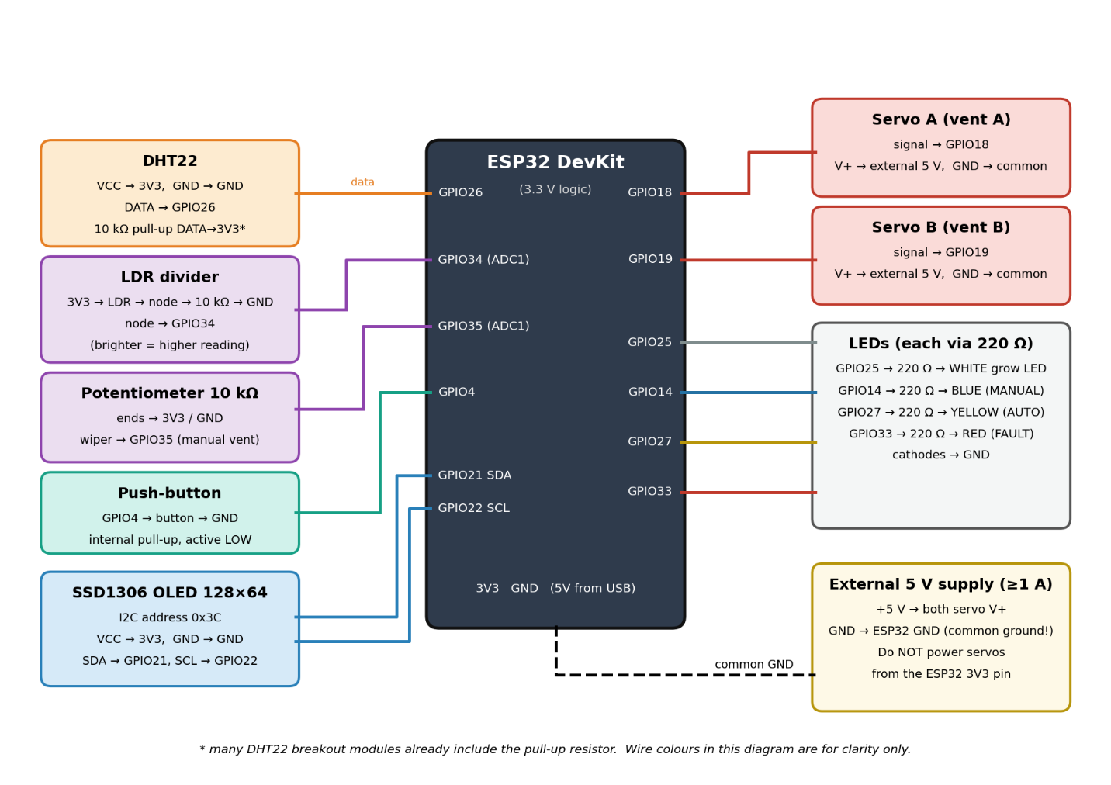

4.2.1 Pin assignment
Component | ESP32 pin | Notes
DHT22 data | GPIO26 | VCC 3.3 V, 10 kΩ pull-up to 3.3 V
LDR divider midpoint | GPIO34 (ADC1) | 3.3 V → LDR → GPIO34 → 10 kΩ → GND
Potentiometer wiper | GPIO35 (ADC1) | Outer pins to 3.3 V and GND
Push-button | GPIO4 | Other side to GND; internal pull-up used
Servo A signal | GPIO18 | Power from external 5 V
Servo B signal | GPIO19 | Power from external 5 V
White grow LED | GPIO25 | Via 220 Ω; PWM dimmed
Blue LED (MANUAL) | GPIO14 | Via 220 Ω; PWM dimmed
Blue LED (MANUAL) | GPIO14 | Via 220 Ω
Yellow LED (AUTO) | GPIO27 | Via 220 Ω
Red LED (FAULT) | GPIO33 | Via 220 Ω
OLED SDA / SCL | GPIO21 / GPIO22 | VCC 3.3 V; address 0x3C

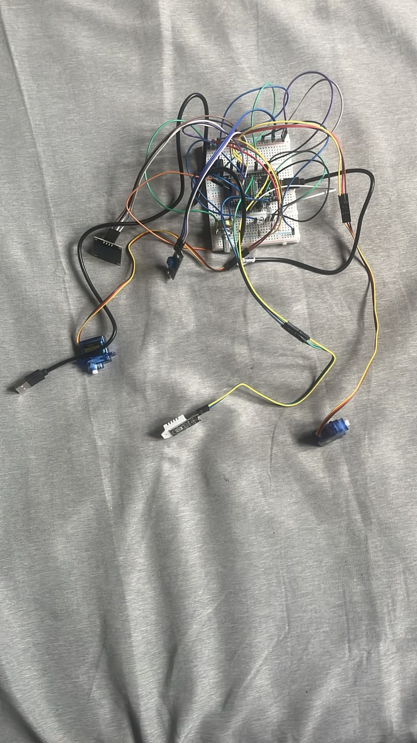
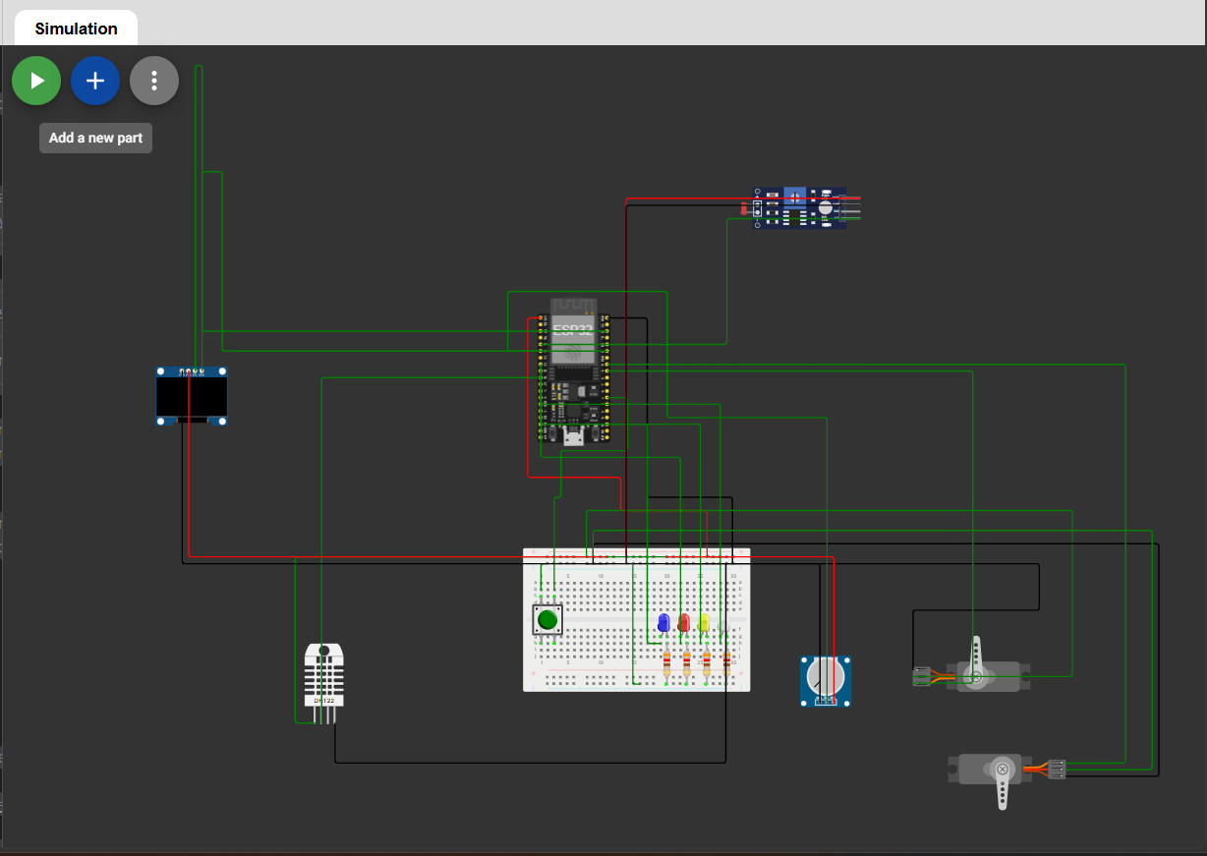

4.3 Programming the ESP32
- Install the Arduino IDE and add the ESP32 board package (Espressif, core 2.x or 3.x).
- Install the libraries Adafruit SSD1306, Adafruit GFX, DHT sensor library and Adafruit Unified Sensor from the Library Manager.
- Open nursery_controller.ino, select "ESP32 Dev Module" and the correct port, then upload.
- Open the Serial Monitor at 115200 baud with the line ending set to "Newline". The command list is printed at start up.

4.4 First Power-Up Check
After reset the OLED shows a start up message and the system enters Autonomous mode (yellow LED). Readings show "--.-" until the first DHT22 sample arrives. Cover the LDR with your hand: the light percentage should fall and the white LED should come on. If the percentage rises instead, the divider is wired the other way round; change LDR_BRIGHT_IS_HIGH to false and upload again.

4.5 Operating Each Mode
Autonomous (yellow LED). No action is needed. The OLED header shows the rule currently in control, for example COOLING, HUMIDITY or FROST CAP. Set points can be adjusted with the "set" command (Table 7); to simulate cold weather, type "set out 2".
Manual Override (blue LED). Press the button once. The OLED shows MANUAL OVERRIDE and "Automation SUSPENDED". Turn the potentiometer to position both vents; turn it fully clockwise to lock them fully open for cleaning. Press the button again to return to Autonomous mode, or let the countdown expire.
Sensor fault (red LED). The red LED blinks once per cycle for a DHT22 fault, twice for an LDR fault and three times for both. The vents move to 30% and the grow light turns off. Check the wiring of the named sensor. When the sensor is working again the red LED stays on steadily; press the button (or type "ack") to return to Autonomous mode. The acknowledgement is refused while the sensor is still failing.
Command | Effect
Help | List commands and current parameter values
status | Print one status line immediately
manual / auto | Enter Manual Override / return to Autonomous (refused during a fault)
ack | Acknowledge a cleared fault
set <param> <value> | Change a set point: vent, band, crit, min, frost, fcap, hum, safe, lon, loff, mto, out
inject dht | ldr | off | Simulate a sensor fault for testing, or clear the simulation

4.6 Troubleshooting
Symptom | Likely cause | Remedy
ESP32 resets when the servos move | Servos powered from the ESP32 | Use the external 5 V supply with a common ground
Servos jitter or do not move | No common ground | Connect supply GND to ESP32 GND
OLED blank; "[OLED] not found" in log | SDA/SCL swapped or wrong address | Check GPIO21/22 wiring; confirm address 0x3C
Immediate DHT22 fault | Missing pull-up or loose data wire | Add 10 kΩ pull up; reseat wires
LDR fault in very bright or dark light | Divider saturates at an ADC rail | Use a different fixed resistor so readings stay mid range
Serial commands ignored | Line ending not set | Select "Newline" in the Serial Monitor

5. Commercial IoT Appraisal
Two commercial systems were chosen, one for glass greenhouses and one for indoor grow rooms, the two environments the scenario sits between.

5.1 Priva Compact CC
Priva Compact CC is an industrial process computer for commercial greenhouses. It integrates control of ventilation, heating, screens, CO2, fans, humidification, lighting and irrigation in one system (Priva, n.d.-a). Its vent strategy is directly comparable to this prototype. Priva describes growers opening the lee-side vent first and the wind-side vent afterwards, with a "lagging" setting that sets the temperature difference between the two (Priva, 2026). The prototype's staged vent A and vent B follow the same principle, but with a fixed 50% split rather than a tunable, wind dependent offset. Priva also supports temporary overrides, such as a crop treatment mode that forces vents closed during spraying and open afterwards; these overrides take priority over normal control (Priva, n.d.-b), just as Manual Override outranks the prototype's automatic rules. The biggest difference is sensing. Priva's weather station measures outside temperature, humidity, wind speed and direction, radiation and rain (Priva, n.d.-c), whereas the prototype relies on an operator entered outdoor temperature.

5.2 TrolMaster Hydro-X Pro
TrolMaster Hydro- X Pro is a modular controller for indoor growing. It combines a 10inch touchscreen with a multi sensor probe measuring temperature, humidity, CO2 and light, supports up to 50 sensors and 50 control modules, and sends alerts through a smartphone app (Hydrobuilder, n.d.). Its safety behaviour is the closest match to this prototype. The lighting control includes an overheat shutdown (TrolMaster, n.d.-a), which is comparable to the prototype's grow light derating during critical heat, and TrolMaster's support guidance states that the controller must have a temperature reading before its lights will operate (TrolMaster, n.d.-b). This is the same reasoning behind the prototype's safe posture, which switches the grow light off when the DHT22 fails. Alerts are sent when a reading leaves the configured range (TrolMaster, n.d.-a), whereas the prototype can only warn people who are standing at the OLED or connected to the serial port.

5.3 Comparison
Aspect | Priva Compact CC | TrolMaster Hydro-X Pro | This prototype
Target setting | Commercial glass greenhouses, multiple compartments | Indoor grow rooms | Single indoor nursery zone (bench scale)
Ventilation | Lee/wind vents with lagging, wind-dependent | Fans and HVAC through device stations | Two staged servo vents with frost cap
Outdoor sensing | Weather station (temperature, RH, wind, rain, radiation) | Not central (sealed rooms) | Operator-entered via UART
Lighting | Integrated lighting control | Dimming, schedules, overheat shutdown | LDR hysteresis, PWM dimming, heat derating
Sensor-loss behaviour | Not detailed in the sources reviewed | Lights require a temperature reading | Latched fault, safe posture, named sensor
Operator override | Temporary overrides with priority | Manual device control | Manual mode with knob and auto resume
Connectivity | Networked, cloud connected options | App, web and cloud alerts | Local OLED and UART only

6. Testing
Each test was run on the physical prototype and repeated in Wokwi where supported, using the UART log as evidence. Sensor faults were produced both by physically disconnecting sensors and with the "inject" commands, which trigger the same fault path in software. Table 10 covers all three modes, the safety logic, the priority hierarchy and edge cases.

Id | Test case | Expected result | Actual result | Pass  /fail
T01 | Power on | AUTO mode, yellow LED on, vents closed, OLED start-up screen then readings | Known limitation. The LDR fault check relies on the reading reaching an ADC rail. In extremely bright or dark conditions a correctly working LDR can approach a rail, so the fixed divider resistor should be chosen so that normal readings stay well inside the range; this is noted in the troubleshooting guide. | pass
T02 | Warm DHT22 to 29 °C (outdoor 20 °C) | COOLING; demand 50%; vent A 100%, vent B 0% | OLED showed "AUTO: COOLING"; serial VentA=100% VentB=0%. | pass
T03 | Warm DHT22 above 32 °C | Demand 100%; both vents fully open | Both vents moved to fully open; serial VentA=100% VentB=100%. | pass
T04 | Indoor 30 °C, "set out 2" | FROST CAP; vents limited to 20% (A 40%, B 0%) | Header changed to FROST CAP; VentA=40% VentB=0%. | Pass
T05 | Indoor ≥ 35 °C with outdoor 2 °C | CRIT HEAT overrides frost; vents 100%; grow light ≤ 30% | Header CRIT HEAT; both vents 100% despite frost; Grow ≤30%. | pass
T06 | Indoor ≤ 16 °C | TOO COLD; vents 0% | Header TOO COLD; vents closed. | Pass
T07 | Indoor 24 °C, RH > 85% | HUMIDITY; vents 25% (A 50%) | Header HUMIDITY; VentA=50% VentB=0%. | pass
T08 | Indoor 26.2 °C (demand < 5%) | Dead-band; vents stay closed | Vents stayed closed (dead-band). | Pass
T09 | Cover LDR (light < 35%) | White LED on; brighter as light falls | Light dropped to __%; white LED turned on and got brighter as it got darker. | Pass
T10 | Light hovering at 40% | Grow light state does not flicker (hysteresis 35-45%) | White LED stayed in the same state with no flicker. | Pass
T11 | Press button in AUTO | MANUAL; blue LED; OLED "MANUAL OVERRIDE"; grow light off | Blue LED on, OLED "MANUAL OVERRIDE / Automation SUSPENDED", white LED off. | Pass
T12 | Turn potentiometer in MANUAL | Both vents follow knob smoothly | Both vents followed the knob smoothly. | Pass
T13 | Potentiometer at end-stop | Both vents follow knob smoothly | OLED showed knob 100%; both vents fully open. | Pass
T14 | Turn potentiometer in AUTO | No effect on vents | Vents did not respond to the knob. | Pass
T15 | set mto 30", enter MANUAL, wait | Countdown shown; AUTO resumes after 30 s; logged | Countdown shown on OLED; returned to AUTO after __ s; serial "[MODE] -> AUTO (manual timeout elapsed)". | pass
T16 | Press button in MANUAL | Returns to AUTO; yellow LED | Returned to AUTO, yellow LED on. | Pass
T17 | Disconnect DHT22 data wire | FAULT within ~4 s; OLED names DHT22; red 1 blink; vents 30%; light off | FAULT after __ s; OLED "Failed: DHT22"; red LED 1 blink; vents 30%; white LED off. | Pass
T18 | Press button while DHT22 still disconnected | Acknowledge refused; message logged; stays in FAULT | Stayed in FAULT; serial "[FAULT] cannot clear - DHT22 still failed". | pass
T19 | Reconnect DHT22 then press button | Red LED solid, then AUTO after button press | Red LED went solid, then AUTO after button press. | Pass
T20 | "inject ldr" | FAULT; OLED names LDR; red 2 blinks | FAULT; OLED "Failed: LDR"; red LED 2 blinks. | Pass
T21 | "inject dht" and "inject ldr" together | FAULT; "DHT22+LDR"; red 3 blinks; OLED "No valid readings" | OLED "DHT22+LDR" and "No valid readings"; red LED 3 blinks. Then inject off + button. | Pass
T22 | Sensor fault while in MANUAL | FAULT; "DHT22+LDR"; red 3 blinks; OLED "No valid readings" | Switched from MANUAL to FAULT; vents moved to 30%. | Pass
T23 | "manual" typed during FAULT | Refused: "clear the fault first (ack)" | Refused: "clear the fault first (ack)". | pass
T24 | "set crit 99" / "set vent abc" | Out of range / not a number; value unchanged | "out of range" and "value is not a number"; help showed values unchanged. | Pass
T25 | Unknown command | "unknown command - type help" | "unknown command - type help". | Pass
T26 | Rapid button bouncing | One mode change per press (250 ms debounce) | One mode change per press; no double switching. | Pass
T27 | Step change 0% → 100% vent demand | Servo moves over ~1.8 s; no ESP32 reset | Vents took about __ s to fully open; ESP32 did not reset. | Pass
T28 | Type a long command while vents are moving | Servos, OLED and LEDs keep updating (non-blocking) | Servos, OLED and LEDs kept updating while typing. | Pass
T29 | Start with OLED disconnected | "[OLED] not found" logged; control continues | Serial "[OLED] not found at 0x3C"; LEDs and servos still worked. | pass
T30 | Compile with all warnings enabled | Builds with no warnings | Built with 0 warnings on ESP32 Arduino core 2.0.9 (-Wall) | Pass

Known limitation. The LDR fault check relies on the reading reaching an ADC rail. In extremely bright or dark conditions a correctly working LDR can approach a rail, so the fixed divider resistor should be chosen so that normal readings stay well inside the range; this is noted in the troubleshooting guide.

Refernces
Espressif Systems (2023) ESP32 Technical Reference Manual. Available at: https://www.espressif.com/sites/default/files/documentation/esp32_technical_reference_manual_en.pdf(Accessed: 25 September 2026).
Hydrobuilder (n.d.) TrolMaster Hydro-X PRO Environmental Control System with 4-in-1 Sensor. Available at: https://hydrobuilder.com/products/trolmaster-hydro-x-pro-environmental-control-system-with-4-in-1-sensor(Accessed: 25 September 2026).
Priva (2026) Tip: Optimizing greenhouse climate with vent control in Priva Connext and Compact CC. Available at: https://www.priva.com/blog/horticulture/tip-optimizing-greenhouse-climate-with-vent-control-in-priva-connext-and-compact-cc(Accessed: 25 September 2026).
Priva (n.d.-a) Priva Compact CC: Manage your essential growing processes. Available at: https://www.priva.com/horticulture/solutions/climate-and-process-computers/priva-compact-cc(Accessed: 25 September 2026).
Priva (n.d.-b) How do I work with temperature influences and temporary overrides? Available at: https://support.priva.com/hc/en-us/articles/360013219331-How-do-I-work-with-temperature-influences-and-temporary-overrides(Accessed: 25 September 2026).
Priva (n.d.-c) Priva Weather Station: For reliable weather measurements. Available at: https://www.priva.com/horticulture/solutions/greenhouse-sensors/priva-weather-station(Accessed: 25 September 2026).
TrolMaster (n.d.-a) Hydro-X Control System HCS-1 user manual. Available at: https://www.trolmaster.com/PDFHtml/HCS-1.html(Accessed: 25 September 2026).
TrolMaster (n.d.-b) Q&A: Support. Available at: https://www.trolmaster.com/News/QandA?class=Support(Accessed: 25 September 2026).

Appendix A - Source Code (nursery_controller.ino)
/**
* @file nursery_controller.ino
* @brief Automated Commercial Micro-Climate Nursery controller (COMP50069, Scenario 2).
* @author M N M Shahmi (CB016484)
*
* @details
* Hardware : ESP32, DHT22, LDR divider, potentiometer (manual vent position
* knob), 2 x servo vents, white grow LED (PWM), yellow (AUTO) /
* blue (MANUAL) / red (FAULT) LEDs, push-button, 128x64 I2C OLED.
*
* Modes : AUTONOMOUS - closed-loop climate control using the priority hierarchy.
* MANUAL - all automation bypassed, vents positioned by the
* potentiometer (turn fully to lock vents open).
* FAULT - a sensor failed; system holds a predefined safe posture
* until the sensor recovers AND the operator acknowledges.
*
* Timing : A 10 ms ESP32 hardware-timer interrupt increments a tick counter.
* loop() never calls delay(); each task runs when its tick interval
* has elapsed (cooperative scheduler).
*
* Libraries: Adafruit SSD1306, Adafruit GFX, DHT sensor library (Adafruit),
* Adafruit Unified Sensor. Works on ESP32 Arduino core 2.x and 3.x.
*/

#include <Arduino.h>
#include <Wire.h>
#include <Adafruit_GFX.h>
#include <Adafruit_SSD1306.h>
#include <DHT.h>
#include <esp_arduino_version.h>
#include "soc/gpio_reg.h" // GPIO register addresses for register-level I/O

/* =====================================================================
* PIN MAP
* ===================================================================== */
#define PIN_DHT 26 /**< DHT22 single-wire data line. */
#define PIN_BUTTON 4 /**< Mode toggle, active low, internal pull. */
#define PIN_SERVO_A 18 /**< Vent A servo PWM. */
#define PIN_SERVO_B 19 /**< Vent B servo PWM. */
#define PIN_LED_WHITE 25 /**< Grow light actuator, PWM dimmed. */
#define PIN_LED_BLUE 14 /**< MANUAL state indicator. */
#define PIN_LED_YELLOW 27 /**< AUTONOMOUS state indicator. */
#define PIN_LED_RED 33 /**< FAULT annunciator, blink coded. */
#define PIN_LDR 34 /**< LDR divider, ADC1 input only. */
#define PIN_POT 35 /**< Manual vent knob, ADC1 input only. */
#define PIN_I2C_SDA 21 /**< OLED I2C data. */
#define PIN_I2C_SCL 22 /**< OLED I2C clock. */

/* =====================================================================
* PWM (LEDC) CONFIGURATION
* Servos share LEDC timer 0 (channels 0/1, 50 Hz). The grow LED uses
* channel 4 (timer 2, 5 kHz) so the two frequencies never clash.
* ===================================================================== */
#define CH_SERVO_A 0 /**< LEDC channel for vent A. */
#define CH_SERVO_B 1 /**< LEDC channel for vent B. */
#define CH_GROW 4 /**< LEDC channel for grow light. */
#define SERVO_FREQ_HZ 50 /**< Standard hobby-servo frame rate. */
#define SERVO_RES_BITS 16 /**< High resolution for smooth angles. */
#define SERVO_PERIOD_US 20000 /**< 1 / 50 Hz. */
#define SERVO_MIN_US 500 /**< Pulse width at 0 degrees. */
#define SERVO_MAX_US 2500 /**< Pulse width at 180 degrees. */
#define VENT_CLOSED_DEG 0.0f /**< Servo angle = vent fully closed. */
#define VENT_OPEN_DEG 90.0f /**< Servo angle = vent fully open. */
#define SERVO_STEP_DEG 1.0f /**< Max movement per 20 ms (slew limit). */
#define GROW_FREQ_HZ 5000 /**< Flicker-free LED dimming. */
#define GROW_RES_BITS 8 /**< 0-255 duty. */

/* =====================================================================
* OLED
* ===================================================================== */
#define OLED_WIDTH 128
#define OLED_HEIGHT 64
#define OLED_ADDR 0x3C

/* =====================================================================
* SCHEDULER (1 tick = 10 ms, generated by hardware timer)
* ===================================================================== */
#define TICK_PERIOD_US 10000UL /**< Hardware timer period. */
#define TICKS_PER_SECOND 100
#define TICKS_SERVO 2 /**< 20 ms - servo slew step. */
#define TICKS_CONTROL 10 /**< 100 ms - ADC read, mode + control. */
#define TICKS_OLED 50 /**< 500 ms - redraw display. */
#define TICKS_DHT 200 /**< 2 s - DHT22 minimum read period. */
#define TICKS_STATUS 500 /**< 5 s - serial status line. */
#define BUTTON_DEBOUNCE_MS 250

/* =====================================================================
* SENSOR VALIDATION
* ===================================================================== */
#define DHT_T_MIN -40.0f /**< DHT22 datasheet lower limit. */
#define DHT_T_MAX 80.0f /**< DHT22 datasheet upper limit. */
#define DHT_FAULT_COUNT 2 /**< Consecutive bad reads before fault. */
#define LDR_RAIL_LOW 10 /**< ADC pinned at 0 V -> short/open. */
#define LDR_RAIL_HIGH 4085 /**< ADC pinned at 3.3V -> short/open. */
#define LDR_FAULT_TICKS 300 /**< Rail must persist 3 s to trip. */
#define LDR_BRIGHT_IS_HIGH true /**< Flip if covering the LDR raises %. */
#define ADC_SAMPLES 8 /**< Oversampling to reduce ADC noise. */
#define POT_SNAP_PCT 3.0f /**< Knob within 3 % of an end snaps to 0 / 100 %. */

/* =====================================================================
* CONTROL CONSTANTS
* ===================================================================== */
#define VENT_DEADBAND_PCT 5.0f /**< Demands below this = fully closed. */
#define HUMID_MIN_VENT_PCT 25.0f /**< Vent opening to break stagnant air. */
#define HEAT_LIGHT_CAP_PCT 30.0f /**< Grow light cap during critical heat.*/
#define GROW_MIN_PCT 20.0f /**< Lowest useful grow-light level. */

/** @brief Operating modes. */
enum Mode : uint8_t { MODE_AUTO, MODE_MANUAL, MODE_FAULT };
static const char *MODE_NAMES[] = { "AUTO", "MANUAL", "FAULT" };

/** @brief Which rule of the priority hierarchy decided the vent position. */
enum Reason : uint8_t {
R_WAIT, R_IDLE, R_COOLING, R_HUMIDITY, R_FROST_CAP,
R_TOO_COLD, R_CRIT_HEAT, R_MANUAL, R_SAFE
};
static const char *REASON_NAMES[] = {
"WAITING", "IDLE", "COOLING", "HUMIDITY", "FROST CAP",
"TOO COLD", "CRIT HEAT", "MANUAL", "SAFE POSTURE"
};

/** @brief Tunable set-points (changeable at runtime over UART). */
struct Config {
float tVent; /**< Indoor temp where venting starts (C). */
float tBand; /**< Rise above tVent that gives 100 % vent (C). */
float tCrit; /**< Critical indoor heat -> vents 100 % (C). */
float tMinIn; /**< Indoor too cold -> never vent (C). */
float tFrost; /**< Outdoor at/below this = dangerous cold (C). */
float frostCapPct; /**< Max vent opening when outdoor is frosty (%). */
float humMax; /**< RH above this -> minimum air-circulation vent. */
float safeVentPct; /**< Vent position held in FAULT mode (%). */
float lightOnPct; /**< Grow light turns ON below this light level. */
float lightOffPct; /**< Grow light turns OFF above this light level. */
float manualTimeoutS; /**< Manual auto-resume time, 0 = never (s). */
float tOutdoor; /**< Simulated outdoor temp, set over UART (C). */
};
static Config cfg = { 26.0f, 6.0f, 35.0f, 16.0f, 5.0f, 20.0f,
85.0f, 30.0f, 35.0f, 45.0f, 600.0f, 20.0f };

/** @brief Live system state. */
struct State {
Mode mode = MODE_AUTO;
Reason reason = R_WAIT;
float tIn = NAN, hum = NAN; /**< Last VALID DHT22 values. */
float lightPct = 0; /**< Light level 0-100 %. */
float knobPct = 0; /**< Manual vent knob 0-100 %. */
uint16_t ldrRaw = 0;
uint8_t dhtBad = 0; /**< Consecutive bad DHT reads. */
uint16_t ldrRailTicks = 0; /**< How long LDR has sat on a rail. */
bool faultDht = false, faultLdr = false;
bool injectDht = false, injectLdr = false; /**< Test hooks (UART). */
float ventDemand = 0; /**< Combined vent demand 0-100 %. */
float tgtA = VENT_CLOSED_DEG, tgtB = VENT_CLOSED_DEG;
float curA = VENT_CLOSED_DEG, curB = VENT_CLOSED_DEG;
bool growOn = false;
float growPct = 0;
uint32_t manualStartTick = 0;
};
static State sys;

static Adafruit_SSD1306 oled(OLED_WIDTH, OLED_HEIGHT, &Wire, -1);
static bool gOledOk = false;
static DHT dht(PIN_DHT, DHT22);

static hw_timer_t *gTimer = nullptr;
static volatile uint32_t gTick = 0; /**< Incremented every 10 ms. */
static volatile bool gButtonFlag = false;
static volatile uint32_t gButtonLastMs = 0;

/* =====================================================================
* INTERRUPT SERVICE ROUTINES
* ===================================================================== */

/** @brief Hardware timer ISR: advances the scheduler tick. */
void IRAM_ATTR onTimerTick() { gTick++; }

/** @brief Button ISR (falling edge) with time-based debounce. */
void IRAM_ATTR onButton() {
uint32_t ms = millis();
if (ms - gButtonLastMs > BUTTON_DEBOUNCE_MS) {
gButtonLastMs = ms;
gButtonFlag = true; // handled in loop(), ISR stays short
}
}

/* =====================================================================
* REGISTER-LEVEL GPIO
* ===================================================================== */

/**
* @brief Set or clear an output pin by writing the GPIO W1TS/W1TC registers.
* @param pin GPIO number (0-39).
* @param on true = HIGH, false = LOW.
*/
static inline void fastWrite(uint8_t pin, bool on) {
if (pin < 32) REG_WRITE(on ? GPIO_OUT_W1TS_REG : GPIO_OUT_W1TC_REG, 1UL << pin);
else REG_WRITE(on ? GPIO_OUT1_W1TS_REG : GPIO_OUT1_W1TC_REG, 1UL << (pin - 32));
}

/** @brief Read an input pin directly from the GPIO_IN registers. */
static inline bool fastRead(uint8_t pin) {
if (pin < 32) return (REG_READ(GPIO_IN_REG) >> pin) & 1UL;
return (REG_READ(GPIO_IN1_REG) >> (pin - 32)) & 1UL;
}

/* =====================================================================
* PWM HELPERS (hide the core 2.x / 3.x LEDC API difference)
* ===================================================================== */

/** @brief Attach a pin to a fixed LEDC channel. */
static void pwmAttach(uint8_t pin, uint32_t freq, uint8_t bits, uint8_t ch) {
#if ESP_ARDUINO_VERSION_MAJOR >= 3
ledcAttachChannel(pin, freq, bits, ch);
#else
ledcSetup(ch, freq, bits);
ledcAttachPin(pin, ch);
#endif
}

/** @brief Write a duty value to a pin/channel. */
static void pwmWrite(uint8_t pin, uint8_t ch, uint32_t duty) {
#if ESP_ARDUINO_VERSION_MAJOR >= 3
(void)ch; ledcWrite(pin, duty);
#else
(void)pin; ledcWrite(ch, duty);
#endif
}

/** @brief Convert a servo angle to a 50 Hz pulse and output it. */
static void servoWriteDeg(uint8_t pin, uint8_t ch, float deg) {
deg = constrain(deg, 0.0f, 180.0f);
uint32_t us = SERVO_MIN_US + (uint32_t)(deg / 180.0f * (SERVO_MAX_US - SERVO_MIN_US));
uint32_t duty = (uint32_t)((uint64_t)us * ((1UL << SERVO_RES_BITS) - 1) / SERVO_PERIOD_US);
pwmWrite(pin, ch, duty);
}

/** @brief Convert a servo angle to vent opening percentage. */
static float ventPct(float deg) {
return (deg - VENT_CLOSED_DEG) / (VENT_OPEN_DEG - VENT_CLOSED_DEG) * 100.0f;
}

/* =====================================================================
* SENSORS
* ===================================================================== */

/** @brief Oversampled ADC read (averages ADC_SAMPLES conversions). */
static uint16_t readAdcAvg(uint8_t pin) {
uint32_t sum = 0;
for (uint8_t i = 0; i < ADC_SAMPLES; i++) sum += analogRead(pin);
return (uint16_t)(sum / ADC_SAMPLES);
}

/**
* @brief Read and validate the DHT22 (every 2 s).
* A reading is rejected if it is NaN or outside the datasheet range.
* Only validated values are stored; the fault trips after DHT_FAULT_COUNT
* consecutive bad reads so one checksum glitch cannot shut the system down.
*/
static void readDht() {
float t = dht.readTemperature();
float h = dht.readHumidity();
bool ok = !sys.injectDht && !isnan(t) && !isnan(h) &&
t >= DHT_T_MIN && t <= DHT_T_MAX && h >= 0.0f && h <= 100.0f;
if (ok) {
sys.tIn = t; sys.hum = h; sys.dhtBad = 0;
} else if (sys.dhtBad < 255) {
sys.dhtBad++;
Serial.printf("[DHT] invalid reading (%u in a row)\n", sys.dhtBad);
}
sys.faultDht = sys.dhtBad >= DHT_FAULT_COUNT;
}

/**
* @brief Read LDR and potentiometer (every 100 ms).
* LDR: converted to 0-100 % light; a reading stuck on either ADC rail for
* 3 s means the divider is open/shorted -> LDR fault.
* Pot: scaled to a 0-100 % manual vent position; the last 3 % at each end
* snaps to fully closed / fully open so "locked open" is easy to reach.
*/
static void readAnalogSensors() {
uint16_t raw = readAdcAvg(PIN_LDR);
sys.ldrRaw = raw;
bool onRail = (raw <= LDR_RAIL_LOW) || (raw >= LDR_RAIL_HIGH);
if (onRail) { if (sys.ldrRailTicks < 60000) sys.ldrRailTicks += TICKS_CONTROL; }
else sys.ldrRailTicks = 0;
sys.faultLdr = sys.injectLdr || (sys.ldrRailTicks >= LDR_FAULT_TICKS);

float pct = raw * 100.0f / 4095.0f;
sys.lightPct = LDR_BRIGHT_IS_HIGH ? pct : 100.0f - pct;

float knob = readAdcAvg(PIN_POT) * 100.0f / 4095.0f;
if (knob < POT_SNAP_PCT) knob = 0.0f;
else if (knob > 100.0f - POT_SNAP_PCT) knob = 100.0f;
sys.knobPct = knob;
}

/* =====================================================================
* MODE MANAGEMENT
* ===================================================================== */

/** @brief Human-readable name of the failed sensor(s). */
static const char *faultName() {
if (sys.faultDht && sys.faultLdr) return "DHT22+LDR";
if (sys.faultDht) return "DHT22";
if (sys.faultLdr) return "LDR";
return "none";
}

/** @brief Switch mode and log the transition. */
static void enterMode(Mode m, const char *why) {
if (m == sys.mode) return;
sys.mode = m;
if (m == MODE_MANUAL) sys.manualStartTick = gTick;
Serial.printf("[MODE] -> %s (%s)\n", MODE_NAMES[m], why);
}

/** @brief Leave FAULT only if every sensor is healthy again. */
static void tryClearFault(const char *src) {
if (sys.faultDht || sys.faultLdr)
Serial.printf("[FAULT] cannot clear - %s still failed\n", faultName());
else
enterMode(MODE_AUTO, src);
}

/** @brief Button press: AUTO <-> MANUAL, or acknowledge a cleared fault. */
static void handleButton() {
switch (sys.mode) {
case MODE_AUTO: enterMode(MODE_MANUAL, "button"); break;
case MODE_MANUAL: enterMode(MODE_AUTO, "button"); break;
case MODE_FAULT: tryClearFault("fault acknowledged by button"); break;
}
}

/**
* @brief Automatic transitions: sensor fault (highest priority, from any mode)
* and the scheduled manual-override timeout.
*/
static void updateMode(uint32_t now) {
if ((sys.faultDht || sys.faultLdr) && sys.mode != MODE_FAULT) {
Serial.printf("[FAULT] sensor failure: %s\n", faultName());
enterMode(MODE_FAULT, "sensor fault");
}
if (sys.mode == MODE_MANUAL && cfg.manualTimeoutS > 0 &&
(now - sys.manualStartTick) >= (uint32_t)(cfg.manualTimeoutS * TICKS_PER_SECOND)) {
enterMode(MODE_AUTO, "manual timeout elapsed");
}
}

/* =====================================================================
* CONTROL LOGIC - THE PRIORITY HIERARCHY
* ===================================================================== */

/**
* @brief Compute vent demand (0-100 %) in AUTONOMOUS mode.
*
* Rules are checked from highest to lowest priority:
* 1. Critical indoor heat -> 100 % (heat damage is fast and irreversible,
* so it outranks outdoor cold).
* 2. Indoor already cold -> 0 % (venting would only cool it further).
* 3. Cooling demand -> proportional to how far above tVent we are.
* 4. High humidity -> at least HUMID_MIN_VENT_PCT to move stagnant air.
* 5. Outdoor frost -> cap the result of 3/4 at frostCapPct so cold
* air enters slowly instead of shocking the crop.
*/
static float computeVentDemand(Reason &why) {
if (isnan(sys.tIn)) { why = R_WAIT; return 0.0f; }
if (sys.tIn >= cfg.tCrit) { why = R_CRIT_HEAT; return 100.0f; }
if (sys.tIn <= cfg.tMinIn) { why = R_TOO_COLD; return 0.0f; }

float d = 0.0f;
why = R_IDLE;
if (sys.tIn > cfg.tVent) {
d = (sys.tIn - cfg.tVent) / cfg.tBand * 100.0f;
why = R_COOLING;
}
if (!isnan(sys.hum) && sys.hum > cfg.humMax && d < HUMID_MIN_VENT_PCT) {
d = HUMID_MIN_VENT_PCT;
why = R_HUMIDITY;
}
if (cfg.tOutdoor <= cfg.tFrost && d > cfg.frostCapPct) {
d = cfg.frostCapPct;
why = R_FROST_CAP;
}
d = constrain(d, 0.0f, 100.0f);
if (d < VENT_DEADBAND_PCT) d = 0.0f;
return d;
}

/**
* @brief Grow-light level with hysteresis (ON below lightOnPct, OFF above
* lightOffPct) and brightness proportional to the light deficit.
* During critical heat the light is capped because LEDs add heat.
*/
static float computeGrowPct() {
if (!sys.growOn && sys.lightPct < cfg.lightOnPct) sys.growOn = true;
else if (sys.growOn && sys.lightPct > cfg.lightOffPct) sys.growOn = false;
if (!sys.growOn || cfg.lightOffPct < 1.0f) return 0.0f;

float pct = (cfg.lightOffPct - sys.lightPct) / cfg.lightOffPct * 100.0f;
pct = constrain(pct, GROW_MIN_PCT, 100.0f);
if (!isnan(sys.tIn) && sys.tIn >= cfg.tCrit) pct = fminf(pct, HEAT_LIGHT_CAP_PCT);
return pct;
}

/**
* @brief Staged venting: vent A covers demand 0-50 %, vent B joins for
* 50-100 %. Small corrections use one vent, big heat loads use both.
*/
static void setVentTargets(float demand) {
float a = fminf(demand * 2.0f, 100.0f);
float b = fmaxf(demand * 2.0f - 100.0f, 0.0f);
sys.tgtA = VENT_CLOSED_DEG + a / 100.0f * (VENT_OPEN_DEG - VENT_CLOSED_DEG);
sys.tgtB = VENT_CLOSED_DEG + b / 100.0f * (VENT_OPEN_DEG - VENT_CLOSED_DEG);
}

/** @brief Decide actuator outputs for the current mode (every 100 ms). */
static void runControl() {
switch (sys.mode) {
case MODE_AUTO:
sys.ventDemand = computeVentDemand(sys.reason);
sys.growPct = computeGrowPct();
break;
case MODE_MANUAL: // automation bypassed, knob drives vents
sys.ventDemand = sys.knobPct;
sys.reason = R_MANUAL;
sys.growPct = 0.0f; sys.growOn = false;
break;
case MODE_FAULT: // predefined safe physical posture
sys.ventDemand = cfg.safeVentPct;
sys.reason = R_SAFE;
sys.growPct = 0.0f; sys.growOn = false;
break;
}
if (sys.mode == MODE_MANUAL) {
// Both vents follow the knob together - no staging in manual.
float deg = VENT_CLOSED_DEG + sys.knobPct / 100.0f * (VENT_OPEN_DEG - VENT_CLOSED_DEG);
sys.tgtA = deg;
sys.tgtB = deg;
} else {
setVentTargets(sys.ventDemand);
}
pwmWrite(PIN_LED_WHITE, CH_GROW, (uint32_t)(sys.growPct * 255.0f / 100.0f));
}

/** @brief Move a value one slew step toward its target. */
static float stepToward(float cur, float tgt) {
if (fabsf(tgt - cur) <= SERVO_STEP_DEG) return tgt;
return cur + (tgt > cur ? SERVO_STEP_DEG : -SERVO_STEP_DEG);
}

/**
* @brief Slew-limited servo update (every 20 ms). Moving 1 degree per step
* avoids current spikes that can brown-out the ESP32.
*/
static void updateServos() {
float a = stepToward(sys.curA, sys.tgtA);
float b = stepToward(sys.curB, sys.tgtB);
if (a != sys.curA) { sys.curA = a; servoWriteDeg(PIN_SERVO_A, CH_SERVO_A, a); }
if (b != sys.curB) { sys.curB = b; servoWriteDeg(PIN_SERVO_B, CH_SERVO_B, b); }
}

/**
* @brief Mode LEDs: yellow = AUTO, blue = MANUAL, red = FAULT.
* Red LED blink code in FAULT: 1 blink = DHT22, 2 = LDR, 3 = both,
* solid = sensors recovered, waiting for acknowledgement.
*/
static void updateIndicators(uint32_t now) {
fastWrite(PIN_LED_YELLOW, sys.mode == MODE_AUTO);
fastWrite(PIN_LED_BLUE, sys.mode == MODE_MANUAL);
bool red = false;
if (sys.mode == MODE_FAULT) {
uint8_t code = (sys.faultDht ? 1 : 0) + (sys.faultLdr ? 2 : 0);
if (code == 0) red = true;
else {
uint32_t phase = (now / 10) % 20; // 100 ms steps, 2 s cycle
red = (phase < code * 2u) && (phase % 2 == 0);
}
}
fastWrite(PIN_LED_RED, red);
}

/* =====================================================================
* OLED
* ===================================================================== */

/** @brief Format a float, or "--.-" if it is not valid yet. */
static void fmtVal(char *buf, size_t n, float v) {
if (isnan(v)) snprintf(buf, n, "--.-");
else snprintf(buf, n, "%.1f", v);
}

/** @brief Draw an inverted title bar. */
static void drawHeader(const char *text) {
oled.fillRect(0, 0, OLED_WIDTH, 10, SSD1306_WHITE);
oled.setTextColor(SSD1306_BLACK);
oled.setCursor(2, 1);
oled.print(text);
oled.setTextColor(SSD1306_WHITE);
oled.setCursor(0, 13);
}

/** @brief Redraw the screen for the current mode (every 500 ms). */
static void drawOled(uint32_t now) {
if (!gOledOk) return;
char t[8], h[8], hdr[24];
fmtVal(t, sizeof t, sys.tIn);
fmtVal(h, sizeof h, sys.hum);
oled.clearDisplay();
oled.setTextSize(1);

switch (sys.mode) {
case MODE_AUTO:
snprintf(hdr, sizeof hdr, "AUTO: %s", REASON_NAMES[sys.reason]);
drawHeader(hdr);
oled.printf("In %sC RH %s%%\n", t, h);
oled.printf("Out %.1fC Lt %.0f%%\n", cfg.tOutdoor, sys.lightPct);
oled.printf("Grow light %.0f%%\n", sys.growPct);
oled.printf("Vent A %.0f%% B %.0f%%\n", ventPct(sys.curA), ventPct(sys.curB));
oled.printf("Set %.1f Crit %.1f\n", cfg.tVent, cfg.tCrit);
oled.print("BTN: manual override");
break;

case MODE_MANUAL: {
drawHeader("MANUAL OVERRIDE");
oled.println("Automation SUSPENDED");
oled.printf("Knob sets vents %.0f%%\n", sys.knobPct);
oled.printf("Vent A %.0f%% B %.0f%%\n", ventPct(sys.curA), ventPct(sys.curB));
oled.printf("In %sC RH %s%%\n", t, h);
if (cfg.manualTimeoutS > 0) {
uint32_t elapsed = (now - sys.manualStartTick) / TICKS_PER_SECOND;
uint32_t left = (elapsed < cfg.manualTimeoutS) ? (uint32_t)cfg.manualTimeoutS - elapsed : 0;
oled.printf("Auto resume %02lu:%02lu\n", (unsigned long)(left / 60), (unsigned long)(left % 60));
} else {
oled.println("No auto-resume");
}
oled.print("BTN: back to AUTO");
break;
}

case MODE_FAULT: {
bool stillFailed = sys.faultDht || sys.faultLdr;
drawHeader("!! SENSOR FAULT !!");
oled.printf("Failed: %s\n", stillFailed ? faultName() : "cleared");
oled.println("Safe posture active");
oled.printf("Vent %.0f%% Grow OFF\n", cfg.safeVentPct);
if (!sys.faultDht) oled.printf("In %sC RH %s%%\n", t, h);
else if (!sys.faultLdr) oled.printf("Light %.0f%%\n", sys.lightPct);
else oled.println("No valid readings");
if (stillFailed) { oled.println("Check sensor wiring"); oled.print("Operator required"); }
else { oled.println("Sensor OK now"); oled.print("Press BTN to resume"); }
break;
}
}
oled.display();
}

/* =====================================================================
* UART - STATUS OUTPUT AND CONFIGURATION INPUT
* ===================================================================== */

/** @brief Runtime-tunable parameters for the "set" command. */
struct ParamDef { const char *key; float *val; float lo, hi; const char *desc; };
static ParamDef PARAMS[] = {
{ "vent", &cfg.tVent, 10, 45, "indoor temp where venting starts (C)" },
{ "band", &cfg.tBand, 1, 20, "rise above vent temp for 100% open (C)" },
{ "crit", &cfg.tCrit, 20, 50, "critical heat, full vent (C)" },
{ "min", &cfg.tMinIn, 0, 30, "indoor too cold, never vent (C)" },
{ "frost", &cfg.tFrost, -10, 15, "outdoor frost limit (C)" },
{ "fcap", &cfg.frostCapPct, 0, 100, "max vent when frosty (%)" },
{ "hum", &cfg.humMax, 40, 100, "humidity for air-circulation vent (%)" },
{ "safe", &cfg.safeVentPct, 0, 100, "FAULT safe vent position (%)" },
{ "lon", &cfg.lightOnPct, 0, 100, "grow light ON below (%)" },
{ "loff", &cfg.lightOffPct, 0, 100, "grow light OFF above (%)" },
{ "mto", &cfg.manualTimeoutS, 0, 7200, "manual auto-resume, 0 = off (s)" },
{ "out", &cfg.tOutdoor, -20, 50, "simulated outdoor temperature (C)" },
};
static const size_t N_PARAMS = sizeof(PARAMS) / sizeof(PARAMS[0]);

/** @brief Print the command list and current parameter values. */
static void printHelp() {
Serial.println(F("\n=== Nursery controller commands ==="));
Serial.println(F(" help | status | manual | auto | ack"));
Serial.println(F(" set <param> <value>"));
Serial.println(F(" inject dht | inject ldr | inject off (fault test hooks)"));
for (size_t i = 0; i < N_PARAMS; i++)
Serial.printf(" %-5s = %7.1f %s\n", PARAMS[i].key, *PARAMS[i].val, PARAMS[i].desc);
}

/** @brief One-line live status (every 5 s and on "status"). */
static void printStatusLine() {
char t[8], h[8];
fmtVal(t, sizeof t, sys.tIn);
fmtVal(h, sizeof h, sys.hum);
Serial.printf("[%s] In=%sC RH=%s%% Out=%.1fC Light=%.0f%% (raw %u) Knob=%.0f%% Grow=%.0f%% "
"VentA=%.0f%% VentB=%.0f%% Why=%s Fault=%s\n",
MODE_NAMES[sys.mode], t, h, cfg.tOutdoor, sys.lightPct, sys.ldrRaw, sys.knobPct,
sys.growPct, ventPct(sys.curA), ventPct(sys.curB),
REASON_NAMES[sys.reason], faultName());
}

/** @brief Handle "set <param> <value>". */
static void setParam(const char *key, const char *valStr) {
if (!key || !valStr) { Serial.println(F("usage: set <param> <value>")); return; }
char *end;
float v = strtof(valStr, &end);
if (end == valStr) { Serial.println(F("value is not a number")); return; }
for (size_t i = 0; i < N_PARAMS; i++) {
if (strcmp(key, PARAMS[i].key) == 0) {
if (v < PARAMS[i].lo || v > PARAMS[i].hi) {
Serial.printf("out of range (%.0f..%.0f)\n", PARAMS[i].lo, PARAMS[i].hi);
return;
}
*PARAMS[i].val = v;
Serial.printf("[CFG] %s = %.1f\n", key, v);
if (cfg.tCrit <= cfg.tVent) Serial.println(F("[CFG] warning: crit should be above vent"));
if (cfg.lightOffPct <= cfg.lightOnPct) Serial.println(F("[CFG] warning: loff should be above lon"));
return;
}
}
Serial.println(F("unknown parameter - type help"));
}

/** @brief Parse and execute one command line. */
static void processCommand(char *line) {
for (char *p = line; *p; ++p) *p = tolower(*p);
char *cmd = strtok(line, " ");
if (!cmd) return;
char *a1 = strtok(nullptr, " ");
char *a2 = strtok(nullptr, " ");

if (!strcmp(cmd, "help")) printHelp();
else if (!strcmp(cmd, "status")) printStatusLine();
else if (!strcmp(cmd, "manual")) {
if (sys.mode == MODE_FAULT) Serial.println(F("clear the fault first (ack)"));
else enterMode(MODE_MANUAL, "serial command");
}
else if (!strcmp(cmd, "auto")) {
if (sys.mode == MODE_FAULT) Serial.println(F("clear the fault first (ack)"));
else enterMode(MODE_AUTO, "serial command");
}
else if (!strcmp(cmd, "ack")) {
if (sys.mode == MODE_FAULT) tryClearFault("fault acknowledged by serial");
else Serial.println(F("no active fault"));
}
else if (!strcmp(cmd, "set")) setParam(a1, a2);
else if (!strcmp(cmd, "inject") && a1) {
if (!strcmp(a1, "dht")) sys.injectDht = true;
else if (!strcmp(a1, "ldr")) sys.injectLdr = true;
else if (!strcmp(a1, "off")) { sys.injectDht = false; sys.injectLdr = false; }
Serial.printf("[TEST] inject dht=%d ldr=%d\n", sys.injectDht, sys.injectLdr);
}
else Serial.println(F("unknown command - type help"));
}

/** @brief Non-blocking serial line reader. */
static void pollSerial() {
static char buf[64];
static uint8_t len = 0;
while (Serial.available()) {
char c = (char)Serial.read();
if (c == '\r' || c == '\n') {
if (len) { buf[len] = '\0'; processCommand(buf); len = 0; }
} else if (len < sizeof(buf) - 1) {
buf[len++] = c;
}
}
}

/* =====================================================================
* SETUP / LOOP
* ===================================================================== */

/** @brief Hardware timer: 10 ms periodic interrupt. */
static void startTickTimer() {
#if ESP_ARDUINO_VERSION_MAJOR >= 3
gTimer = timerBegin(1000000); // 1 MHz timer clock
timerAttachInterrupt(gTimer, &onTimerTick);
timerAlarm(gTimer, TICK_PERIOD_US, true, 0); // auto-reload
#else
gTimer = timerBegin(0, 80, true); // 80 MHz / 80 = 1 MHz
timerAttachInterrupt(gTimer, &onTimerTick, true);
timerAlarmWrite(gTimer, TICK_PERIOD_US, true);
timerAlarmEnable(gTimer);
#endif
}

void setup() {
Serial.begin(115200);

pinMode(PIN_LED_BLUE, OUTPUT);
pinMode(PIN_LED_YELLOW, OUTPUT);
pinMode(PIN_LED_RED, OUTPUT);
pinMode(PIN_BUTTON, INPUT_PULLUP);
pinMode(PIN_LDR, INPUT);
pinMode(PIN_POT, INPUT);
attachInterrupt(digitalPinToInterrupt(PIN_BUTTON), onButton, FALLING);

analogReadResolution(12);

pwmAttach(PIN_SERVO_A, SERVO_FREQ_HZ, SERVO_RES_BITS, CH_SERVO_A);
pwmAttach(PIN_SERVO_B, SERVO_FREQ_HZ, SERVO_RES_BITS, CH_SERVO_B);
pwmAttach(PIN_LED_WHITE, GROW_FREQ_HZ, GROW_RES_BITS, CH_GROW);
servoWriteDeg(PIN_SERVO_A, CH_SERVO_A, VENT_CLOSED_DEG);
servoWriteDeg(PIN_SERVO_B, CH_SERVO_B, VENT_CLOSED_DEG);
pwmWrite(PIN_LED_WHITE, CH_GROW, 0);

Wire.begin(PIN_I2C_SDA, PIN_I2C_SCL);
Wire.setClock(400000); // faster redraw (~25 ms)
gOledOk = oled.begin(SSD1306_SWITCHCAPVCC, OLED_ADDR);
if (gOledOk) {
oled.clearDisplay();
oled.setTextColor(SSD1306_WHITE);
oled.setTextSize(1);
oled.setCursor(0, 20);
oled.println("Micro-Climate Nursery");
oled.println("Starting...");
oled.display();
} else {
Serial.println(F("[OLED] not found at 0x3C - check SDA/SCL wiring"));
}

dht.begin();
startTickTimer();
printHelp();
Serial.println(F("[MODE] -> AUTO (power on)"));
}

void loop() {
static uint32_t tServo = 0, tControl = 0, tDht = 0, tOled = 0, tStatus = 0;

pollSerial();
if (gButtonFlag) { gButtonFlag = false; handleButton(); }

uint32_t now = gTick;
if (now - tServo >= TICKS_SERVO) { tServo = now; updateServos(); }
if (now - tDht >= TICKS_DHT) { tDht = now; readDht(); }
if (now - tControl >= TICKS_CONTROL) {
tControl = now;
readAnalogSensors();
updateMode(now);
runControl();
updateIndicators(now);
}
if (now - tOled >= TICKS_OLED) { tOled = now; drawOled(now); }
if (now - tStatus >= TICKS_STATUS) { tStatus = now; printStatusLine(); }
}

